Obamacare Page 1,004: You Must Have RFID Chip Implanted in Your Body

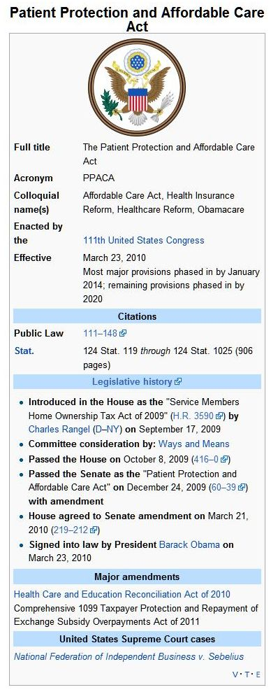
wikipedia.org/wiki…
Another hidden secret in Obamacare “RFID Chip Implants”
by Mr. Charrington on May 26, 2011
On Sunday March 21, 2010 the Senate Healthcare bill HR3200 was passed and signed into law the following Tuesday. Like I said before, there are a lot them by now. I don’t want to discount them but what cannot be missed here is this new law now opens a prophetic door on a magnitude not seen since the reformation of Israel.
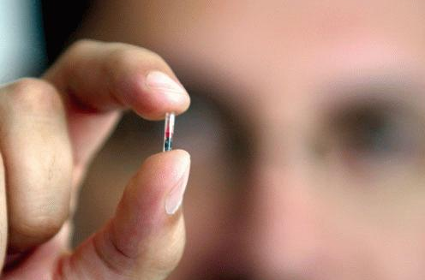
This new law requires an RFID chip implanted in all of us. This chip will not only contain your personal information with tracking capability but it will also be linked to your bank account. And get this, Page 1004 of the new law (dictating the timing of this chip). Reads and I quote: “Not later than 36 months after the date of the enactment”. It is now the law of the land that by March 23rd 2013 we will all be required to have an RFID chip underneath our skin and this chip will be link to our bank accounts as well as have our personal records and tracking capability built into it.
In just s minute I’m going to show you the black and white of the law itself and you can see it with your own eyes and wonder why an event of this magnitude which is nothing less than seismic in nature is met with little more than silence in the Christian community.
Is it now starting to dawn on you just where exactly we are in prophecy? I’ll ask that question again in a minute and follow up on it, but now I want to show you the law itself. I’ve downloaded a PDF copy of HR3200 from the government’s website so what I’m about to show you is from the bill itself its nothing that I’ve written. You can access it all and see it all for yourself straight from the source itself.
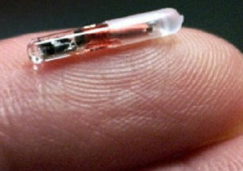
H.R.3200 section 2521, Pg. 101, paragraph1.
The Secretary shall establish a national medical device registry (in this subsection referred to as the ‘registry’) to facilitate analysis of postmarket safety and outcomes data on each device that—“is or has been used in or on a patient; “and is—“a class III device; or “a class II device that is implantable, life-supporting, or life-sustaining.”
What exactly is a class II device that is implantable? As you saw earlier, it is the device approved by the FDA in 2004.
Federal Food, Drug, and Cosmetic Act:
Http://www.fda.gov/downloads/MedicalDevices/DeviceRegulationandGuid...
A class II implantable device ia an “implantable radio frequency transponder system for patient identification and health information.” The purpose of a class II device is to collect data in medical patients such as “claims data, patient survey data, standardized analytic files that allow for the pooling and analysis of data from disparate data environments, electronic health records, and any other data deemed appropriate by the Secretary.”
Going back to what we just looked at, the creation of the national medical device registry in section 2521, page 1002 line 5:
“In developing the registry, the secretary shall…”
And the law continues on with a laundry list of items that the secretary must do in the process of creating this registry. In this laundry list of items to do. Line 17, subparagraph B; “validating methods for analyzing patient safety and outcomes data from multiple sources and for linking such data with the information included in the registry as described in subparagraph (A)”
Going back to subparagraph A [right above subparagraph B], it says: “including in the registry, in a manner consistent with subsection (f), appropriate information to identify each device described in paragraph (1) by type, model, and serial number or other unique identifier;”
Don’t be confused by the intentional obfuscation and stillful wording, This law first creates the national device registry and then immediately list all the task the secretary of health and human services will have do in the process of creating this registry.
The very first two items in the list mandates that the secretary first gives a unique identification to each of the items listed in paragraph 1 which is:
“a class III device; or “a class II device that is implantable.”
Then, the very next thing the secretary is to do is to create the process by which “patient safety and outcomes data from multiple sources”. Which is electronic medical records, that are linked to those newly and uniquely identified items from paragraph 1 which are the class III and class II implantable devices.
Class III devises are items such as breast implants, pacemakers, heart valves, etc. A Class II device that is implantable is, as you seen from the FDA, an implantable radio frequency transponder, RFID chip. From breast implants, to pacemakers, to RFID chips which one is the only possible one that can used for the stated purpose in section B which is, “for linking such data with the information included in the registry”? As we know from subsection A, the information in the registry is the name of a device. In plain speak, we are in a clear way being told that our electronic medical records are going to be linked to a class II implantable device!
Continuing a few lines down in this same section, section B subsection ii on still on page 1002, the “patient safety and outcomes data from multiple sources”, that is to be linked is clearly spelled out as electronic medical records. It reads: “link data obtained under clause (i) with information in the registry”. Information in the registry is, as we know from subparagraph A, the name of the device. So what is the data obtained under clause i? Back up a few lines to clause i
It reads: “obtain access to disparate sources of patient safety and outcomes data, including Federal health-related electronic data”. Again, from breast implants, to pacemakers, to RFID chips which one is the only possible one that can used for the stated purpose in section B? That stated purpose is “for linking such data” and the such data is electronic medical records.
What we already have already seen in just the creation of this registry, is the device that will serve as the link, which is an RFID microchip that is categorized as a Class II implantable device, as well as what it will be the link for which is your electronic medical records.
In case the law wasn’t clear enough on that point, still in the laundry list of things to do a few more lines down on the next page, page 1005
“The Secretary to protect the public health; shall establish procedures to permit linkage of information submitted pursuant to subparagraph (A, remember subparagraph A is the class 2 implantable device reference) with patient safety and outcomes data obtained under paragraph (3, which is electronic medical records); and to permit analyses of linked date;”
Continuing on to page 1007, in the STANDARDS, IMPLEMENTATION CRITERIA, AND CERTIFICATION CRITERIA section, the secretary of health and human services is given full power to intact all mandates from the laundry list of to-do items in the creation process of the registry as well as dictate how the devices listed in the National Medical Device Registry are to be used and implemented.
“The Secretary of the Health Human Services, acting through the head of the Office of the National Coordinator for Health information Technology, shall adopt standards, implementation specifications, and certification criteria for the electronic exchange and use in certified electronic health records of a unique device identifier for each device described in paragraph 1 (National Medical Device Registry), if such an identifier is required by section 519(f) of the Federal Food, Drug, and Cosmetic Act (21U.S.C. 360i(f) for the device.”
Now on Page 503, section E Lines 13-17 and I quote: “encourage, as appropriate, the development and use of clinical registries and the development of clinical effectiveness research data networks from electronic health records, post marketing drug and medical device surveillance efforts”. Let me say that again, medical device surveillance efforts!
Now lets look at section 163 of HR3200, which gives the government a direct electronic access to your bank account which will work in conjunction with as implanted chip.
Page 58 Lines 5 through 15 reads:
(D) enable the real-time (or near real time) determination of an individual’s financial responsibility at the point of service and, to the extent possible, prior to service, including whether the individual is eligible for a machine-readable health plan beneficiary identity detection card; € enable, where feasible, near real-time adjudication of claims
What does this mean? It means that the government will give everybody a health ID card that contains a machine readable device (magnetic strip or RFID chip) similar to a credit card. Embedded in this ship or strip is your Health Identification Number. When you visit a medical provider, the medical claims will be processed while you are still in the office. The medical providers will be paid in real time. The portion that you owe will be deducted from your bank account, in real time. According to HR 3200.
Notice here in this part which is at the beginning of 2000 plus pages of the law, it is carefully worded “which may include utilization of a machine-readable health plan beneficiary identity detection card”. Here we are told that it may be a card. As you have already seen, deeper in the law [Sec. 2521 Pg. 1000] what this “may” utilize is clearly spelled out as a “class II device that is implantable”.
We can only speculate at this point why the law is set up this way. Most likely this section was written to account for the gap in time from when the process of chipping begins to when everyone has received a chip. A means of starting with a card for the sake of expedience while the process of chipping citizenry plays out. One thing is certain, the law mandates that within 3 years we will all have a chip under our skin that will serve this purpose.
Evidence of this logic is found in the deadline set for the start of the registry on page 1006.
“EFFECTIVE DATE.—The Secretary of Health and Human Services shall establish and begin implementation of the registry under section 519(g) of the Federal Food, Drug, and Cosmetic Act, as added by paragraph (1), by not later than the date that is 36 months after the date of the enactment of this Act, without regard to whether or not final regulations to establish and operate the registry have been promulgated by such date.”
Also on page 259, this law requires the use of Electronic medical records system in all hospitals by 2012 which will leave a gap of at least a year before the class II implantable device is required.
Republican Congressman Ron Paul from Texas, states on his website: www.ronpaul.com
“Buried deep within the ever 1,000 pages of the massive US Health Care Bill (PDF) in a “non-discussed” section titled: Subtitle C-11 Sec. 2521–National Medical Device Registry, and which states its purpose as….He quotes that part of the law and then goes on to say: “In “real world speak”, according to this report, this new law, when fully implemented, provides the framework for making the United States the first Nation in the World to require each and every one of its citizens to have implanted in them a radio-frequency identification microchip for the purpose of controlling who is, or isn’t, allowed medical care in their country”.
That is from a currently serving member of congress. Cutting through all the political ease, the bottom line is that eventually if you want to participate in a government healthcare plan you will have to have this chip implanted in you. This law mandates that you have to have insurance and by virtue of this law guarantees that all private healthcare insurers will be driven out of business with only the government option left. We will be in a single payer system and you will have to have an imbedded ship to be a member of this system and it is mandatory that you be a part of this system.
When I have a number of different pieces of data, I like to lay it all out in bit size pieces so the picture becomes clearer so I’m going to lay out the data and cut through the political circular logic and legal ease:
2004:
Class II implantable devices receive FDA approval and verchip VeriMed electronic health records system also received approval from the FDA.
2009:
American Recovery and Reinvestment Act authorized $23 billion in stimulus funds for health care information technology. In conjunction with that, VeriChip re-launches VeriMed electronic health records system which is a system that is made up of implantable-RFID microchips, handheld scanners for emergency room personnel to read these chips, and online electronic personal health records.
2010:
HR3200 was passed by the House and signed into law by the president
Now looking at the new law, Page 259 Electronic Medical Records system will be required for all healthcare providers by 2012.
Pages 1001-1002:
A national medical device registry is created and populated with devices. Chiefly noted among them, a Class II medical device that is implantable.
Pages 1002-1004:
Mandates the use of class II implantable devices to serve as the link between you and your electronic medical records.
Page 1005:
The secretary of human services will establish the procedures for the linking of the Class II implantable device and electronic medical records.
Page 1007:
Secretary of health and human services is given full power to intact all items required in the creation of the registry as well as the power to dictate how the devises listed in the National Medical Device Registry are to be used and implemented.
Page 503:
Medical device surveillance is authorized.
Page 58:
The link to your electronic medical records which is the Class II implantable device will also be linked to your bank account.
Page 1006:
Without regard to whether or not final regulations are in place, you will be required to get a Class II implantable device linked to your medical records and bank account in order to participate in the government healthcare plan.
Pages 155-158:
It is mandated that you have health insurance or you will pay $100.00 dollars per day that you are not covered.
Page 159:
The IRS will enforce healthcare enrolment and fines for not carrying health insurance.
Lastly:
This law mandates that you have to have insurance and by virtue of this law, guarantees that all private healthcare insurers will be driven out of business with only the government option left. We will be in a single payer system and you will have to have an imbedded chip to be a member of this system and it is mandatory that you be a part of this system.
This new law, when fully implemented, provides the framework for making the United States the first nation in the world to require each and every one of its citizens to have implanted in them a radio-frequency identification microchip. In theory, the intent to streamline healthcare and to eliminate fraud via “health chips” seems right. But, to have the world’s lone superpower mandate a device to be IMPLANTED is not just scary. It is prophetic!
Is this in its current form the mark of the beast? No it is not. The Bible is clear that this will not become the mark of the beast until midway through tribulation when it is somehow associated with a sign of allegiance to the antichrist and it is in some way imprinted with a number or symbols associated 666.
However this is the very mechanism by which it will happen and obviously since the mark will be on a global scale, this has not fully played out. Keep in mind though; we are already staring down the barrel of a global government who will implement this on a global scale. Also, the rapture is a game changing event. If the global government hasn’t come to fruition at the point of the rapture, it will overnight when the rapture happens and this law will be applied across the board. I wouldn’t be surprised if same healthcare ruse won’t be applied under the premises that the mass disappearance of people is a global healthcare emergency and the application of this law [globally and under a global government] will prevent others from disappearing or at a minimum be a means of determining what happened via the tracking capability inherent to RFID chips.
Now I’m going to ask you the question that I asked earlier: Is it now starting to dawn on you just where exactly we are in prophecy? By virtue of the fact that this hasn’t sent tremors through the Christian community, one can only assume that community is asleep at the wheel. Maybe everyone is so bogged down in all the other evil facets to this new law that this has slipped through the cracks. I tend to doubt that is the case though. I think the reason that hardly no one has seemed to even so much as mentioned this is because human nature is kicking in and it’s hard to get past the logical mind when it is telling your that this just can’t be or this is somehow a misrepresentation of the new law and all those who had a part in it. Mixed in with that, no one wants to risk their reputation or for some their ministries reputation by saying something that could get them labeled as conspiracy nut.
Captain Edward Smith, captain of the titanic said this statement shortly before the titanic embarked on its maiden voyage:
“I cannot imagine any condition which would cause a ship to founder. I cannot conceive of any vital disaster happening to this vessel. Modern shipbuilding has gone beyond that.”

The point here is that people to tend see and believe what they want to see and believe and in this case, what’s easiest to not see and not believe.
All that you have seen so far is a matter of fact and easily investigated by yourself. So I say again, is it now starting to dawn on you just where exactly we are in prophecy?
Romans 13:11
And do this, understanding the present time. The hour has come.
http://www.therightplanet.com/2012/07/obamacare-page-1004-you-must-have-rfid-chip-implanted-in-your-body/
http://www.patriotactionnetwork.com/forum/topics/another-hidden-secret-in
http://www.youtube.com/watch?v=Pu2Uyua0so8

